A GREAT SUMMER NIGHT OUT!

Fine Dining at Innocenti / Toronto the Good at Artword Theatre
Artword Theatre is right across the street from one of  Toronto’s most delightful restaurants–Innocenti.  Atmosphere: relaxed elegance  Cuisine: Mediterranean  Quality: superb  This summer, Artword and Innocenti are combining to offer the best dinner/show package in town.  Tuesday, Wednesday, Thursday, Friday, Saturday:  Dinner at 6:30,  at 8:30  Saturday matinee:   at 4:00, Dinner at 6:30  $49 per person / seniors/student $39 per person  Innocenti Restaurant & Bar (Mediterranean)  587 King Street, Toronto M5V 1M5, Ontario  Tel: +1 416 203 0551 Fax: +1 416 203 0553 |  |  | 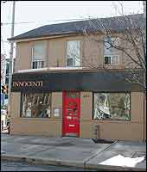
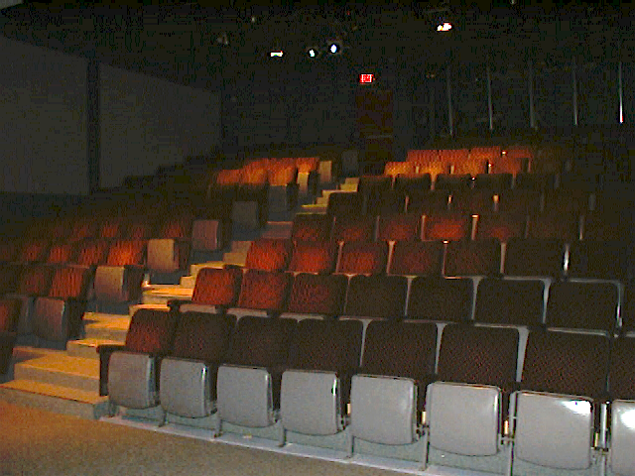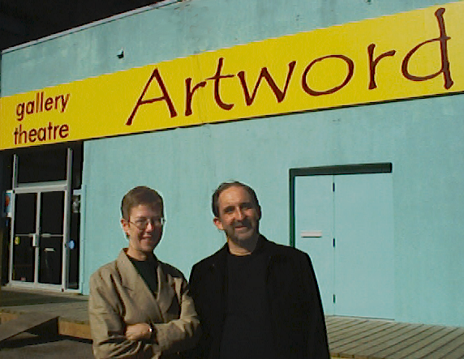
Where is Artword Theatre? (see map on our website www.artword.net for more information)
Address: | 75 Portland Street, Toronto, ON M5V 2M9
Location: | One block east of Bathurst, just south of King
Box Office #: | 416-366-7723 (St. Lawrence Centre Ticket Line)
If you drive: | From Gardiner Expressway, take Spadina exit north to Front and east to Portland. From Lakeshore Blvd., go north on Bathurst to Stewart and turn right to Portland.
Parking: | Street parking along King, Stewart, Wellington. Nearby lots are west on Stewart, north on Portland, east on King, and south on Front
Public Transit: | King streetcar (#504) stops at Portland.
Services in area: | Many nearby restaurants and pubs.
Toronto the Good: A musical about Toronto in the 1890s
Written and directed by: Ronald Weihs
Musical Direction: Thomas Baker
Dates: June 18 to July 28, 2002 (previews June 14, 15, 16 mat.)
Times: Tues-Fri at 8:30 pm; Sat at 4 & 8:30 pm; Sun at 3 pm
Tickets: Dinner/Show $49/ $39 seniors and students
$27 regular, $20 seniors and students
Where: Artword Theatre, 75 Portland Street, Toronto (one block east of Bathurst, south of King)
Call: Advance Tickets - 416-366-7723 (St. Lawrence Centre Ticket Line) Artword Info Line – 416 –408-2783 (ARTD)

