Artword Theatre 1999-2002

A Theatre and an Art Gallery in Downtown Toronto
Artistic Director: Ronald Weihs Managing Director/Curator: Judith Sandiford
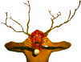 |  |  |  |  |  |  |  | 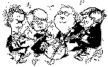 |  |  |  |  |  |  | 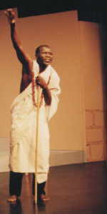 |  |  |  |  |    |  |  |  |  | 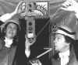
 |  |  |  |  |  |  |  | 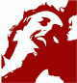 |  |  |  |  |  |  |  |  |  |  |  | 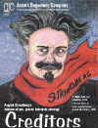 |  |  |  |  | 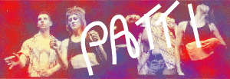

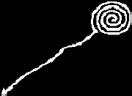

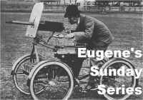
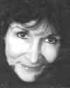 |  | 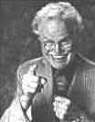 |  | 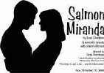 |  |  |  |  |  |  |  |  |  |  | 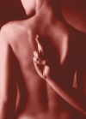 |  |  |  |  | 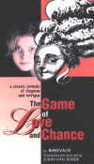
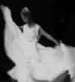 |  |  | 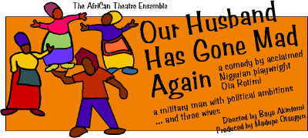 |  |  |  |  |  |  |  | 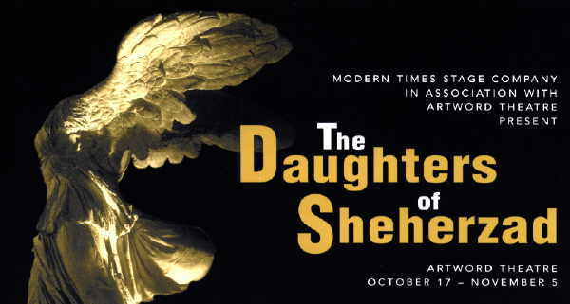 |  |  |  |  |  |  |  |  |  |  |  |  |  | 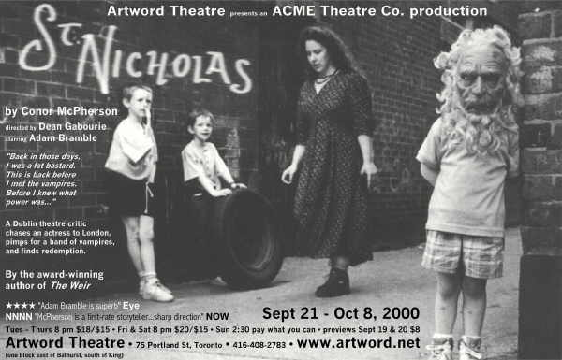
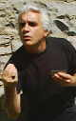 |  |  | 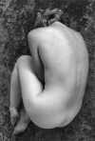 |  | 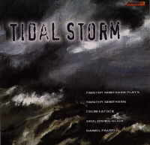 |  |  |  | 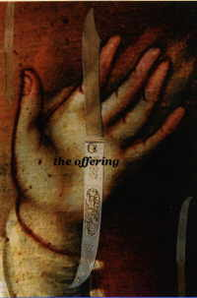 |  |  |  |  | 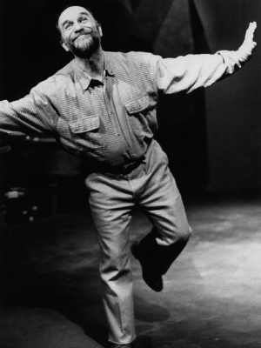 |  |  |  |  | 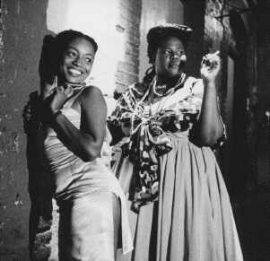 |  |  |  | 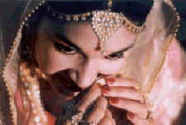
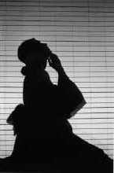 |  |  | 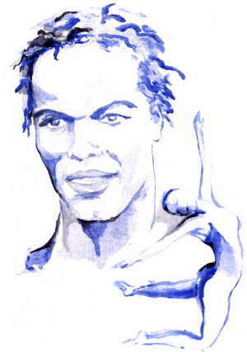 |  | 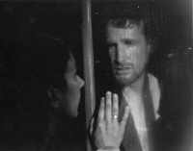 |  |  |  |  |  |  |  | 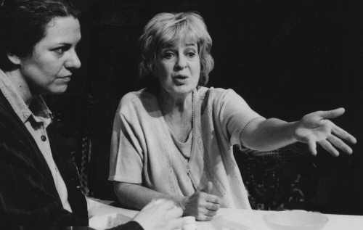 |  |  |  |  |  |  |  |  | 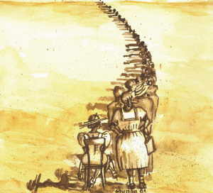 |  |  | 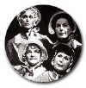
 | 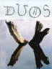 |  |  |  | 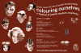 |  |  |  |  | 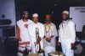 |  |  |  |  |  | 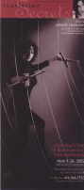 |  | 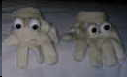 |  |  |  |  |  |  |  | 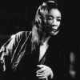
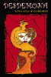 | 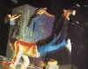 |  |  |  | 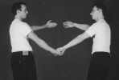 |  |  |  |  |  |  | 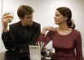 |  |  |  |  | 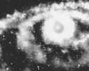 |  |  |  | 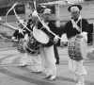 |  |  | 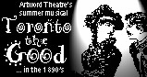

Artword’s Mission:
To provide an environment for artists to create the best work of which they are capable and to share that work with the Canadian public.

Core values:
We treat everyone equitably and with respect.
We maintain a positive, humane and nurturing environment for artistic creation.
We treat our audience with respect, presenting work that is relevant and appealing to them.
As artists, we embrace the risks and the responsibilities for what we produce.
We respect and encourage a wide variety of artistic expression.
We strive to build a spirit of community among artists.
We believe that all the arts and creative processes should work with one another.
We present work that we believe in, that affirms the human spirit, that embodies artistic energy and commitment, and that strives to improve the human condition.

Artword’s Mandate

Goal:
To create and maintain an arts facility consisting of a theatre, an art gallery and other spaces for artistic production and administration.

Objectives:
To develop and present new works of art by Canadians and others, as well as contemporary interpretations of traditional works of art, in the areas of theatre, visual art, literature, dance, music and multimedia.
To present plays, concerts, dance performances and other performing arts events.
To curate and exhibit contemporary visual art.
To publish and disseminate literary works and commentary on the arts and contemporary life.
To provide and maintain a forum for communication among artists and people who care about the art.

Artword is
A haven for like-minded artists, created by a playwright/director and a visual artist as a context for sharing work and insights with a community of people who choose to communicate through the arts.
An ongoing experiment in finding new ways of producing art and artistic events, using the resources of the early 21st century.
A theatre combining a friendly, unpretentious atmosphere with a strong commitment to presenting exciting, original and well-crafted dramatic productions.
An art gallery, exhibiting visual art in the context of the broader spectrum of the arts.
A performing arts laboratory for theatre, dance, concerts and multimedia.
A production company, committed to developing new work and creating a distinctive style of theatre characterized by strong ensemble acting, eloquent language, inventive use of music, movement and dance, and striking visual design.
A magazine. Artword Artists Forum published quarterly for seven years (also under the name Workseen Magazine), providing a vehicle for dialogue among visual artists.
A state of mind, characterized by belief in the human spirit, commitment to human dignity and delight in the human imagination.

Artword Chronology
1993
November | Judy and Jazz, featuring science fiction writer Judith Merril and master jazzman John T. Davis.
 | Bush News, Beauvais and Books, an evening of classical guitar improvisations by William Beauvais and poetry performance by Doleske.
December | Sounds and Clowns, Nobuo Kubota with Peter Jarvis and friends.
 | Mama Says: You Are What You Do, workshop presentation of a new musical by Ronald Weihs.
1994
January | Black Bride an original play written and performed by Andrew Kelm. Music Performance by Robert Simms.
 | The Original Mendelson Joe No Smoke Night:, the legendary Mendelson Joe, songwriter and artist
 | Aboriginal to Avant Garde, Paul Dutton and Curtis Dreidger, voice/violin duet; Ali Kushkani, santur
February | The Dalai Lama's Pyjamas, readings by Peter Such, flamenco dance with Luna Yatsula and Pedro El Ingles.
 | One Man Double Bill: crooner/performer Roger Clown!
 | Stories from Elsewhere: Stories of Ottawa by André Alexis to music by Andrew Miller, read by Russ Manson and André Alexis. Readings from Pants on Fire by Ken Garnhum.
 | Sounds and Clowns II: Peter Jarvis and special guests, including Carol Bruce and Haven, Mark Sepic, Sue Morrison, Nancy McColl and a percussion ensemble.
March | Artword Theatre presents Mama Says: You Are What You Do,: a musical play written and directed by Ronald Weihs, a full mainstage full, with Scott Bell, James Kirchner, Catherine Smith, Rhonda Lee Stephenson, James Thompson
April | Dreams for Sale: An evening of original songs by Carol Bruce and traditional folktales by Jim Meeks.
 | Making Theatre in the '90s: A brainstorming session.
 | Love Minus One: Prose, poetry and Russian music featuring Norma Harrs, Elisavietta Ritchie and Nina Shapilsky.
May | HANA - The Garden of the Senses: a collaborative performance of dance, music and visuals with Meiko Ando, Go Hirano, Dominique Pepin and Roderick Zalameda.
June | Songs of Pain, Passion, Pleasure, Loss, Sex, Death, Surrealism, Despair, Angst and Nova Scotia: with Mhairi Fyfe (vocals) and Archie Hughes (keyboard).
 | Afterthoughts: Dramuse (actor Carolyn Guillet and guitarist William Beauvais) perform Gwendolyn McEwen's last work, Afterworlds. Followed by Cafe Improv, with violist Julian Knight.
 | Hartzedike-Lider (Heartsongs): Actor, vocalist, storyteller Allan Merovitz and guitarist/composer Brian Katz experiment with traditional Jewish music.
 | Dreams for Sale: Brand New Dreams: An evening of stories and songs by songwriter Carol Bruce and storyteller Jim Meeks.
July | me2: A play exploring the split between a woman's inner self and the reflected self she exhibits to the world. Performed by Mhairi Fyfe with music by Archie Hughes, directed by Ronald Weihs.
October | A Couple of Larrikins: Geoff Goodfellow, Australian performance poet and Toronto's Robert Priest.
 | Word-Body-Sound: Two writer/performers, TaylorJane Green and Pauline Peters.
 | Wood between Worlds: an evening of sonare acoustique music by Roderick Zalameda, metal sculptures by Julie Pickard.
November | Mythologies: music with text from Gwendolyn MacEwen's The Arcana of the Kings and Terror and Erebus, performed by William Beauvais, Carolyn Guillet, Julian Knight and Eugene Martynec.
 | Journals and Other Personal Narratives: readings by Vancouver's Renee Rodin and Toronto's jwcurry.
 | The Life and Work of Irrevella de Puis: by Larry Lewis. Workshop production directed by Jennifer Brewin, with Ranki Helmers, Martha Ross, Patrick Conner and music by Delawareness.
 | The Paradigm Shift (or No Mo' Pomo): an irreverent puppet performance by the Necessary Corrective Collective, Tony Arnold, Joyce Kline and Iris Paabo.
December | Happy Fish Café: concert by Cyrus, songwriter/guitarist, accompanied by tabla and mridangam, with special guests including Jon Magidsohn and Kiran Ahluwalia.
 | Virago!: a celebration of the Bold and Boisterous Feminine Spirit, featuring four enormous Goddess Sound Sculptures, created by Amanta Scott with David Tomlinson.
1995
 | Journey Through a Blind Man's Passion:a multi-media performance by artist/ poet Philip Read, combining music, poetry, video, movement and action painting.
February | Women, Gods, Beasts, Love by cellist Brenda Muller, flautist Laurie Glencross, and actress Randi Helmers. Includes folksongs, classical music, poetry by Sappho, Ovid, Homer, T.S. Eliot and a shadow puppet ritual.
 | Cassandra and the Monks theatre excerpts from The Greeks about Cassandra, the mad priestess of Troy, by actor Carolyn Guillet, followed by musical improvisations by members of the Subtonic Monks ensemble.
 | The Niece’s Tale Storyteller Shawna Watson picks up the threadof the story that Chaucer’s Wife of Bath left untold - what happened to the woman who was raped? With folksinger Eve Goldberg.
 | Pulse Form Variations: Keyboardist Tim Minthorn’s ensemble performs new compositions for piano, percussion and saxophone.
March | Cool Fools Cabaret: Peter Jarvis and the Subtonic Monks, including dance, mask, mime and improvisation.
 | Joseph Maviglia: Poet/songwriter Joseph Maviglia and guest musicians, including Anne Lederman, Jane Miller and Steve Starchev perform songs and tales of working class blues and urban grind.
 | Heteroactive Poet Leonard Gasparini, musicians Geordie McDonald and Rob Caroll, dancers Pam Johnson and Michael Kaplan.
May | Sola Collektiva 1995: dance/multimedia performance with Meiko Ando, Go Hirano, Roderick Zalameda
 | Piano Party, celebrating the arrival of the new Artword baby grand piano, with Eric Cobhamn, Brenda Muller and Ardeleana, Mark Julson, Timothy Minthorn.
 | Artword Festival of the Human Voice: How many ways to tell a story? Festival featuring Dan Yashinsky, Oliver Schroar, Miki Sakurai, William Beauvais, Linda Eyman, Allan Gasser, Julian Knight, lJoan Bodger, Charly Chiarelli, Shawna Watson, Yolande Sery, Jean-Paul Ako Béché, Justine Gogoua, Emmanuel Douho, Allan Merovitz, Brian Katz, Brenda Muller, Laurie Glencross, Ann Edwards, Carolyn Guillet, Eric Cobham and Theodore Gentry. With an exhibition of paintings by Anthony Arnold.
June | Chaucer’s Troilus and Criseyde: a new theatrical adaptation by Ronald Weihs of Geoffrey Chaucer’s classic love story. Music by Timothy Minthorn. With Scott Bell, Hedy Minten, Michael Spence and James Thomson.
September | Shaking the Blues Away, with Jerelyn Craden, accompanied by Mike Lewis.
October | New Jazz Compositions by Timothy Minthorn, performed by the Timothy Minthorn Ensemble, with Daniel Rubinoff, James Thomson, Ariel Misken, and Ilios Steryannis.
 | Paintings by Bill Kort
November | Happy Fish Café, Cyrus and friends:
 | Me-Klo (Mon Village), an evening with le groupe Bassan from Africa’s Ivory Coast.
 | Songline: The Shaman’s Journer, a concert by the Ardeleana Chamber Trio, Brenda Muller, Laurie Glencross, and Ann Edwards, with actor Carolyn Guillet.
December | Allan Merovitz’s Chanukah Party, with Allan Merovitz and the Simcha Klezmer Band, Wally Brooker, Jim Gelcer, Allan Merovitz, Sageev Oore, Johann Van De Ven, Martin Van De Ven.
1996
February | Oswald von Wolkenstein: The Performance, featuring Larry Lewis and Brian Katz, directed by Allan Merovitz, written by Larry Lewis, set by Jane Low Beer, hats by Karen Krupa.
 | The Age of Dorian (workshop presentation), an Operatic Play by Greg Morrison, directed by Sandra Balcovske, with Steve Morel, Doug MacNaughton, Ed Sahely, Glynis Ranney, Gretchen Helbig, Andrew Stelmack, Karen Hines, Jonathan Wilson, Robert MacAulay, and Keram Milicki Sanchez.
March | Composers’ Soiree, a monthly series of new works, begins.
 | Geography, paintings by Andrew Glinski.
 | Echo and Narcissus: A Mirror for Our Time, conceived and directed by Ronald Weihs, choreographed and performed by dancers Hedy Minten and Michael Du Maresq.
 | Seiren, concert by the Ardeleana chamber trio, Brenda Muller, Laurie Glencross, Ann Edwards, with special guest Nancy De Long, mezzo-soprano.
April | Cu’Fu - Stories from a Sicilian Family, written and perfomed by Charly Chiarelli.
May | Festival of the Human Voice, 1996, with Lorne Brown, Judith Cohen, Cyrus, Susan Davy, Michael Du Maresq, Sharon Dyer, Mhairi Fyfe, Shelley Hines, Archie Hughes, Brian Katz, Greg Lambert, Derrick Lewis, Larry Lewis, Carol McGirr, Hedy Minten, Nobuo Kubota.
 | Artemis Café, a cabaret written by Brenda Muller, performed by Nancy DeLong, Laurie Glencross, Carolyn Guillet, Brenda Muller, with shadow art by Anthony Arnold.
September | Cu’Fu (Stories from a Sicilian Fmily), written and performed by Charly Chiarelli (through October).
October | A Deconstructed Dollhouse, conceived and performed by Margaret Dragu.
November | Run of Cu’Fu extended to December 15.
 | Concert performance of Mozart’s Don Giovanni, presented by Opera Anonymous
 | Letters Launches Lyon, by Pierre L’Abbé, book launch, featuring readings from the book by Mary Elizabeth Grace, Bill Kennedy, A.F. Moritz, Chris Pannell and the author, with music by Chip Yarwood.
 | Lasting Impressions, organized by Maureen Gauthier, an information resource centre for artists, artisans and conservators about art materials and techniques.
 | Workshop performance of first act of Heloise, a new opera by William Beauvais (music) and Judith Sandiford (libretto), performed by Linda Eyman, Alan Gasser and Timothy Minthorn. Part of an evening of new works, including works by Colin Eatock, Timothy Minthorn and David Parsons.
1997
Jan/Feb | Artword stage expanded by knocking down a wall, doubling the playing area.
March | Composers’ Soirée, featuring four arias from Heloise, by William Beauvais (music), Judith Sandiford (libretto).
 | Circus Gothic, by Jan Kudelka, performed by Jan Kudelka, music by Cameron Shook.
April | The Lecture, written and performed by Linda Brokenshire, directed by John Turner, a clown lecture.
May | The Age of Dorian, by Greg Morrison, a musical theatre adaptation of Wilde’s The Picture of Dorian Gray, directed by Sandra Balcovske, with Steven Morel, Todd Stewart, Amanda Leigh, Andrew Pifcoe, Andrew Stelmack, Gretchen Helbig and Robert Miller.
 | Daniel Rubinoff, classical saxiphonist, in concert with Gloria Saarinen, piano, playing from his new CD, The Old Castle., featuring works by Shumann, Vaughn Williams and Srul Irving Glick.
June | Nipplefish, the next wave, a concert by Cyrus and friend.s
July/August | James Howard gives acting classes at Artword.
October | The Greenwood Trio in concert, Gloria Saarinen (piano), Mary Delli Colli (mezzo) and David Dunbar (tenor/actor), with special guests form the Dixon Hall Music School.
 | Multimedia and poetry performances, part of the First Acorn/Livesay People’s Poetry Festival, with Clifton Joseph, Georie McDonald, Eric Ruly, July McNeill, Simon Frank, Uncritical Mass and Joe Blades.
November | Whoever You Are, written and directed by Ronald Weihs, based on a science fiction story by Judith Merril, with Hume Baugh, Don Ciaschini, Rhonda Lee Stephenson and Chad Hershler, music by Eugene Martynec and Geordie McDonald.
December | Concert Performance of first act of Heloise, a new chamber opera by William Beauvais (music) and Judith Sandiford (libretto), performed by Linda Eyman (soprano), Alan Gasser (tenor), Paul Oros (baritone), with MarieLine Ross (piano).
 | CD Release Party for Silica, by Eugene Marynec, featuring dancers Carly Wong and Michael DuMaresq
 | Goblin Market, Christina Rossetti’s classic poem told by Clare Nobbs, storyteller.
1998
February | Sad, Sorrowful and Downright Morbid, songs and stories from the Southern Appalachian mountains, performed by Jim Meeks (storyteller), Janis McCallen (singer) and Tom Warney (guitar and banjo).
March | Homo Habilis (Man Good With His Hands), written and performed by Andrew Kelm.
 | March 11 - First announcement of move to new space.
April | Dancing Barefoot with Patti, choreographed by Michael DuMaresq, danced by Leanne Dixon, also on the program: Blue Button and Parenthetical Pillows.
 | Mixed Company Weekend Workshop, given by Simon Malbogat.
May - Nov | Building the new theatre in a former garment factory.
December | Hard Hat Party, organized by Robert Tomas.
 | Special presentation of Homo Habilis, by Andrew Kelm.
1999
April | Artword opens our new 150 seat theatre and 1500 square foot gallery at 75 Portland Street.
 | Artemis Theatre's The Facetious Penguin Inquest, an on-going investigation into the arts produced by Carole Logan.
 | Artword Gallery opens our first exhibition in the new space, Monad: Photographs of Flowers and Other Singular Compositions by Wayne Parent, part of Contact ’99 Toronto Photography Festival.
May | May 1999 Ala-Turka and Mixed Company present Merhaba/Bonjour/Hello!
June | Artword Theatre celebrates our new space with The Artword Festival, Five nights of dance, storytelling, poetry, music and theatre.
 | AfriCan Theatre Ensemble presents The Gods Are Not To Blame, a Nigerian classic by Ola Rotimi, based on the Oedipus legend, with a cast of 30 actors, singers, and drummers
 | Artword Gallery: Hourglass Memories, An exhibition of paintings and drawings by Rejeanne Lizotte.
 | Artword hosts on-going drawing, painting and illustration classes with Jane Gibson.
July | Artword Gallery: States and Transformations: The Lithograph Project by Judith Sandiford.
 | Artword and Canboulay Dance Theatre present Luminessence.
 | b current presents a workshop of coming of a nu don (hip hop adaptation of Shakespeare’s Twelfth Night).
Aug | Artword hosts the launch party for fFIDA, the Fringe Festival of Independent Dance Artists.
 | Artword Theatre presents Revealing Gestures, an off-fFIDA event of four dance works.
 | Big Smoke Productions presents Somewhere by Conor Green.
 | Nova’s Wake Theatre presents American Dream Queen by Edward Griffith in a double bill of new plays.
 | Artword Gallery: Private, A series of 12 oil paintings by Chris Ross.
September | Amati Quartet presents the first in a series of Rush Hour Concerts.
 | Actors’ Repertory Company in association with Artword present Creditors by August Strindberg, directed by John Neville.
 | Artword Gallery: South of the Border, new paintings by Andrew Glinski.
 | Artword hosts it’s Patrick CD release party, with stage sculptures by TemperMettle.
 | Artword hosts on-going dance classes by Canboulay Dance Theatre.
October | Bam Boom Productions presents Sonofadrum, written and performed by Bill Usher, directed by Luciano Iogna.
 | Artword presents the revival of Dancing Barefoot with Patti and Other Works, choreographed by Michael Du Maresq, based on the poetry of Patti Smith.
 | Artword hosts the Listen Up! 2000 Storytelling Festival Lottery Evening.
 | Artword hosts Over the Edge, an advanced actors’ workshop by Steven Rumbelow.
 | In the studio: Offshoots presents works-in-progress by Norma Araiza, Lee Pui-Ming, Eryn Dace Trudell, Rebecca Todd and Allison Ulan.
 | Artword Gallery presents Serial Works paintings and drawings by Barbara Caruso.
November | Artword presents Mizu Tubiq Thani Collection of Water, A dance/music collaboration by Meiko Ando, Roderick Zalameda, Cyrus Sundar Singh and Go Hirano.
 | Hear Here presents The Green Pants, a family-friendly new music event, featuring the Dr. Seuss story, with dancer Yvonne Ng.
 | Seventeen Steps Productions presents a reading of Sherlock Holmes and the First English Gentleman, by Doug Warwick, directed by Anne Butler.
 | Artword Gallery: Press Zero, works by Tracey Bowen, Eva Chris Goldberg and David McClyment.
 | Artword hosts a meeting of the Portland Residents’ Association.
December | Artword presents the return of Cu’Fu, ? written and performed by Calogero (Charly) Chiarelli.
 | Miniatures in Motion’s Giselle, performed in miniature in the world’s smallest computer-automated theatre.
2000
January | Thorablot Productions and Vertical Management Group present Que Sera: The Life of Doris Day, written by Claudette Williams, directed by Rebecca Cann.
 | Artword Gallery presents Landscape in the Artword and Sandiford Collections.
Feb. 2000 | Artword presents If Cows Could Fly (How to Grow Up Jewish in Smiths Falls), written and performed by Alan Merovitz, directed by Ronald Weihs.
 | Banshee Theatre presents a workshop production of The Shining Star in the studio, by Andrew Akman
 | Zoijka Productions presents The 401 Dance Collision, six choreographers from Montreal and Toronto.
 | Artword hosts Magic Mirror: Transformation through Romantic Love, a course taught by June Lawton and Andrew Kelm.
March | Artword hosts the launch and benefit screening of Smack, By Steve Sanguedolce for the Canadian Filmmakers Distribution Centre.
 | Moriah Productions presents The Offering, a new play by Anton Piatagorsky, directed by Chris Abraham.
 | In the studio, The Soul Walking, By Sara Tilley, directed by Kyle Brough.
 | Artword Gallery: C. Herbert: Blowup, digital manipulation/drawing/painting works by Claude Breeze.
 | Artword hosts a series of seminars and cafes organized by Dance Umbrella of Ontario.
April | Artword hosts One Night Stand, an evening of play readings to benefit the Playwrights Union of Canada.
 | Artword hosts a free piano concert by Timothy Minthorn, to celebrate the release of the CD Tidal Storm.
 | Autumn Leaf Performance presents Pierrot Lunaire & Transfigured Night, by Arnold Schoenberg, directed by Thom Sokoloski, performed by Fides Krucker.
 | Artword hosts M’Bemba Bangoura, a West African dance immersion workshop series.
May | Pleiades Theatre presents The Game of Love and Chance by Marivaux, translated and directed by John Van Burek.
 | Artword Gallery: Certified Quality Snapshots as part of Contact 2000, the Toronto Photography Festival, curated by Catherine Lash and Jennifer Long.
 | That Sunday Thing At Artword is launched with a series of three informal concerts in the Gallery, featuring new compositions and the talents of a dozen young local musicians.
 | Artword launches a late-night series with Keeping Mum by Richard Harris, performed by Irena Hull.
June | The AfriCan Theatre Ensemble presents Our Husband Has Gone Mad Again by Nigerian playwright Ola Rotimi. The author is guest of honour at a gala performance and gives a workshop about his plays.
 | In the studio, a free workshop production of Three Hotels by Jon Robin Baitz, directed by Chuck Shamata.
 | Artword hosts a benefit concert for Music Toronto and the Gryphon Trio, to raise funds for the production of Constantinople, composed by Christos Hatzis.
July | Artword participates as a new venue for the Toronto Fringe Festival.
 | Artword Gallery presents our First Annual Drawing Show, Thin Black Line, featuring works by 10 artists
August | Artword participates as a venue for the SummerWorks Theatre Festival
 | Hear Here Productions presents A Summer Night Concert: George Crumb: Madrigals; Piazzola: L’Histoire du Tango; Patti Smith: My Madrigal; Improvisations.
September | Art exhibit Subterrene by Margaret Chen, installation by Margaret Chen with performance by dancer/choreographer Peter Chin.
 | Concert by Nancy White, Canada’s foremost songwriting satirist, accompanied by Bob Johnston (piano and backup vocals), with special guests featuring stars of the new Artword season.
 | Artword Theatre presents St. Nicholas by Conor McPherson, the brilliant one-man play by the author of The Weir, directed by Dean Gabourie, starring Adam Bramble.
 | ARC Reading Series (Sept - June). A regular series of play readings on the first Monday of the month.
October | Eugene’s Sunday Series, a weekly exploration in new music, new collaborations, new media organized and hosted by Eugene Martynec. Special Concert in November 26, 8 pm, Geordie McDonald, percussionist.
 | Modern Times Stage Company: a new collaborative play, The Daughters of Sheherzad.
November | Susanna Hood and hum present Still, a new work by dancer/choreographer Susanna Hood.
 | Artword Theatre presents Salmon Miranda, by Leah Davidson, directed by Sarah Armstrong, with Leah Davidson as Miranda, Christopher Morris as Sam.
December | In the Depths of My Palais Canboulay Dance Theatre transforms Artword into a festive Caribbean Palais
 | Artword Theatre presents I’m Dreaming of a Nancy White Christmas Nancy White, that funny lady, back by popular demand, in a seasonal concert.
2001
January | Disco Goalie by Jane Miller. It’s funny, it’s sexy, it’s hockey!. Jane Miller’s solo show.
 | Michael Trent, dancer and choreographer presents The Memory Show, new works
February | Artword Theatre presents Cu’Fu? written and performed by Charly Chiarelli, directed by Ronal Weihs, back for another mainstage run. The hit show that toured the country and played on BRAVO television. Hilarious and touching stories about growing up Sicilian in Hamilton.
March | Dancer and choreographer Eryn Dace Trudell teams with pianist Boo Watson
 | Pleasure Dome's project: A Blueprint for Moving Images in the 21st Century. Nine artists unveil their speculations on what role moving images might play in the new century -- Roberto Ariganello, Judith Doyle, Jeremy Drummond, Linda Feesey, Helen Hill, Robert Lee, Maija Martin, Andrew J. Paterson and Ho Tam.
 | March Break special for kids! Brick Bros. Circus by Puppetmongers: The renowned Puppetmongers and their circus troupe of flying bricks!
 | Woman as Landscape: Lin Snelling, dancer and choreographer and Michael Reinhart, designer, composer and photographer, in a multi-media performance produced by the Theatre Centre.
April | Artword Theatre presents Mangiacake!: World premiere of Charly Chiarelli's brand new show! Charly goes back to Italy and finds out he isn't as Sicilian as he thought. In fact he's a MANGIACAKE! Written and performed by Charly Chiarelli and directed by Ronald Weihs.
May | Pleiades Theatre presents The Triumph of Love, a classic comedy written by Marivaux, translated & directed by John Van Burek. With Philippa Domville, Paul Fauteux, Allan Hawco, Ross Manson, Amy Price-Francis, Michael Spencer-Davis, Helen Taylor.
June | Claudia Moore's Moonhorse Dance Theatre presents Small Midnight An evening of dance choreographed by Tedd Robinson and Claudia Moore, performed by Fiona Drinnan, Bonnie Kim, Claudia Moore, Miko Sobreira
 | Artword Theatre presents a remount of If Cows Could Fly written and performed by Allan Merovitz, directed by Ronald Weihs, with Klezmer and Yiddish music by the Simcha Klezmer Band (Jarl Anderson on piano and mandolin, Ronald Weihs on fiddle)
July | Princess Productions presents Stone Velvet, an evening of dance performed by Yvonne Ng and Robert Glombek
 | From Trinidad, Jean and Dinah... Who have been locked away in a world famous calypso since 1956 speak their minds publicly. Written and directed by Tony Hall, starring Rhoma Spencer and Penelope Spencer.
August | Artword participates again as a venue for the SummerWorks Theatre Festival
September | Rasik Arts presents Umrao: based on the classic Urdu novel about the adventure-filled life of a 19th century courtesan in Lucknow, India.
 | Artword Gallery: Peter Harris Woven tapestries, Tapestry: an overused metaphor; a bricklayer’s art; the opposite of a snapshot.
 | Ota: An adaptation of Robert Lepage’s The Seven Streams of the River Ota, directed and adapted by Stephanie Saunders. OTA is comprised of three of the original “seven streams.”
 | The Chairs: inaugurates the new Artword Alternative space. Soheil Parsa (Modern Times Stage Company) directs this wild and wonderful production of Eugene Ionesco’s absurdist play.
 | Exile Literary Quarterly: issue 25.2 launch. Art reception with an exhibition of Mexican artists.
 | ARC Reading Series (Sept - June). A regular series of play readings on the first Monday of the month.
October | The AfriCan Theatre Ensemble presents And the Girls in Their Sunday Dresses, a play by South African author Zakes Mda. With keen humour and a sense of the absurd, this 1988 play, both foresees the end of apartheid and warns of other dangers that face the new South Africa.
 | Eugene Martynec’s Sunday improvisational series featuring: new music, new media, and new collaborations.
 | Artword Gallery: Bruce Parsons, Re-Visions: For World Leadership. An exhibition of constructions, laser inkjet prints on canvas and vinyl banners.
 | Canboulay Dance Theatre Dancer / choreographer Ronald Taylor pays tribute to the pioneers of the steel drum in his latest work, Symphonic Steel. Featuring six dancers.
 | In the Artword Alternative, Miss Begotten a powerful drama by Kevin Land based on the life of Diane Esther, author of Out of Incest and Abuse, A Book of Hope.
November | Artword Theatre presents Night, Mother the Eclectic Theatre production of the Pulitzer prize-winning play by Marsha Norman starring Jayne Eastwood and Alison Smiley.
December | Book launch by poet Allan Briesmaster, with art by Holly Briesmaster and music by Larry Webb, Lynn Harrison and friends.
 | The second Bohemian Embassy Night, hosted by Don Cullen, a cabaret evening in support of the Humanist Society of Toronto. Headlined by comedian/singer Nancy White, with poet George Miller (the Bohemian Embassy’s poet laureate) and the Hasek family of musicians and singers.
2002
January | Beggarly Productions presents The Bush-Ladies the story of our first Canadian women authors: Susanna Moodie, Catharine Parr Traill, Anne Langton and Anna Jameson. These cultivated English gentlewomen are totally unprepared for what they find in the New World.
 | Portrait Productions presents Desdemona: A Play about a Handkerchief by Paula Vogel,.a deconstruction of Shakespeare's Othello, directed by Sue Miner, starring Brooke Johnson, Sarah Neville and Anita La Selva.
February | DUOS Une collaboration entre le metteur en scène Guillaume Bernardi et la poète francophone Anne Nenarokoff-Van Burek. In French, with English texts of the poems provided.
 | Ethnic Heritage Ensemble - 25th Anniversay Concert. The renowned jazz trio of Kahil El'Zabar, Joseph Bowie and Ernest "Khabeer" Dawkins.
March | Charly Chiarelli in Mangiacake! Charly goes back to Italy and finds out he isn't as Sicilian as he thought.
 | Colouring Ourselves: a festival of Jewish student creativity presents the theatre/dance/poken word element of their program at Artword.
 | I Furiosi Baroque Ensemble presents an evening of staged cantatas with music by Bach and Monteclair. Stage direction by Guillaume Bernardi. Guest soloist baritone Brian McMillan. I Furiosi: Aisslinn Nosky and Julia Wedman, baroque violins; Felicity Deak, baroque ‘cello; Gabrielle McLaughlin, soprano.
 | I Want All That . . . (and a bag of chips) Rachael Griffith and Ari Wormeli, new talent out of York University, bring their puppetry to Artword. The show uses many kinds of puppets.
 | Dancer/choreographer Michael DuMaresq's new work and in this room . . ., an exploration of childhood memories, opening the doors of our past. With dancers Leanne Dixon, Darryl Tracy and Bonnie Kim.
April | FADO presents talking to my horse, a new performance by Vancouver-based First Nations artist Archer Pechawis. FADO hosts a talk by Pechawis.
 | Artword Theatre presents Onibaba, a dance work in the Butoh style based on Japanese legends of the witch Onibaba, created by dancer/choreographer Meiko Ando, with music performed by Roderick Zalameda and visual design by Judith Sandiford
 | Theatre Gargantua and UK's 2021 Performance: Phantom Limb, written by Spencer Hazel, a bold new work with movement, text, video and music that explores the impact of loss and separation
 | East West Theatre Company presents the Canadian premiere of David Mamet's The Old Neighborhood, directed by John Gordon.
May | Pleiades Theatre presents Counterfeit Secrets by Marivaux, translated and directed by John Van Burek. Starring Arsinée Khanjian, Andrew Pifko, Xuan Fraser, Julie LeGal, William Webster and René Lemieux. Sparkling comedy about the ambguous relationship between love and money. An English-Canadian premiere
 | Reaching Symmetries presents Quintessence a new play by Stephen Near, directed by Lisa Rothman. “Four people confront the turmoil of their lives after the death of woman who has touched them all."
June | Charles Hong presents Jeng Yi, performing Samulnori, the folk music traditon of Korea, "to play four things" (small gong, large gong, hourglass drum, bass drum), an evening of song, dance and drumm.
 | Toronto the Good! Artword Theatre's summer musical. Written and directed by Ronald Weihs. A musical with singing, dancing and general carrying-on, based on 1890’s original sources: (gossip columns, court reports, temperance tracts, investigative journalism, song sheets, vaudeville routines, and more!

